## Introduction

The following Eclipse preference settings should be used by all Notification Server developers and testers.

## Java – Code Style – Formatter

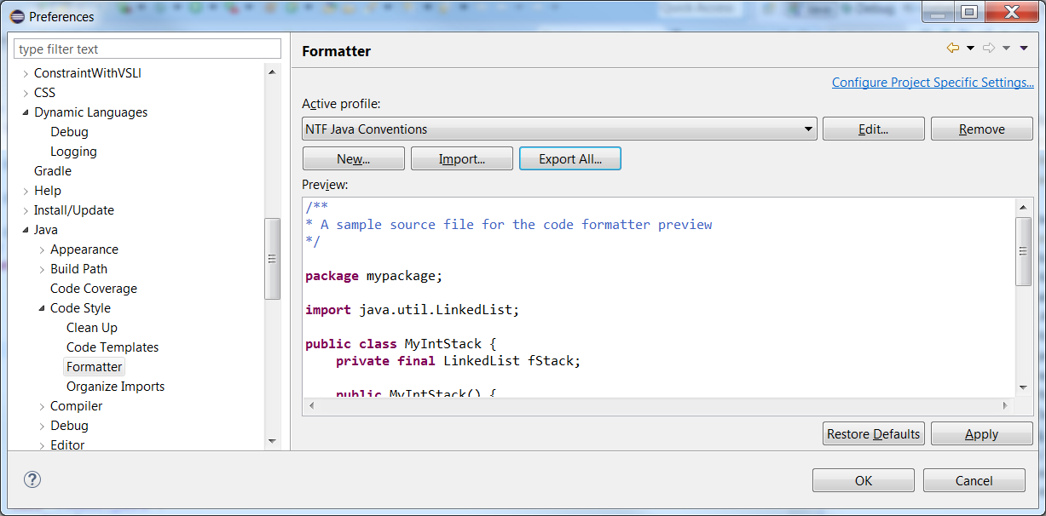

Conventions File is attached 

Save to directory and import into Eclipse.

## Java – Editor – Save Actions

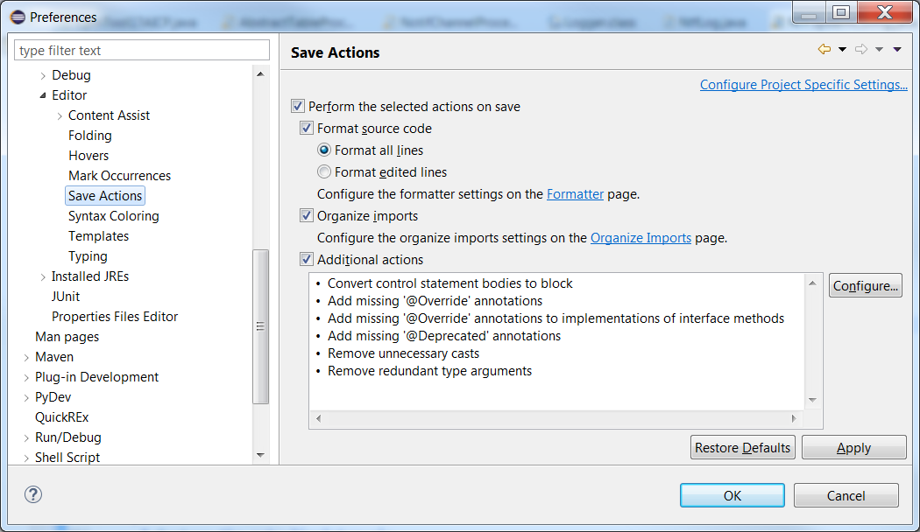

## Java – Compiler – Errors/Warnings

The following preferences should be set.

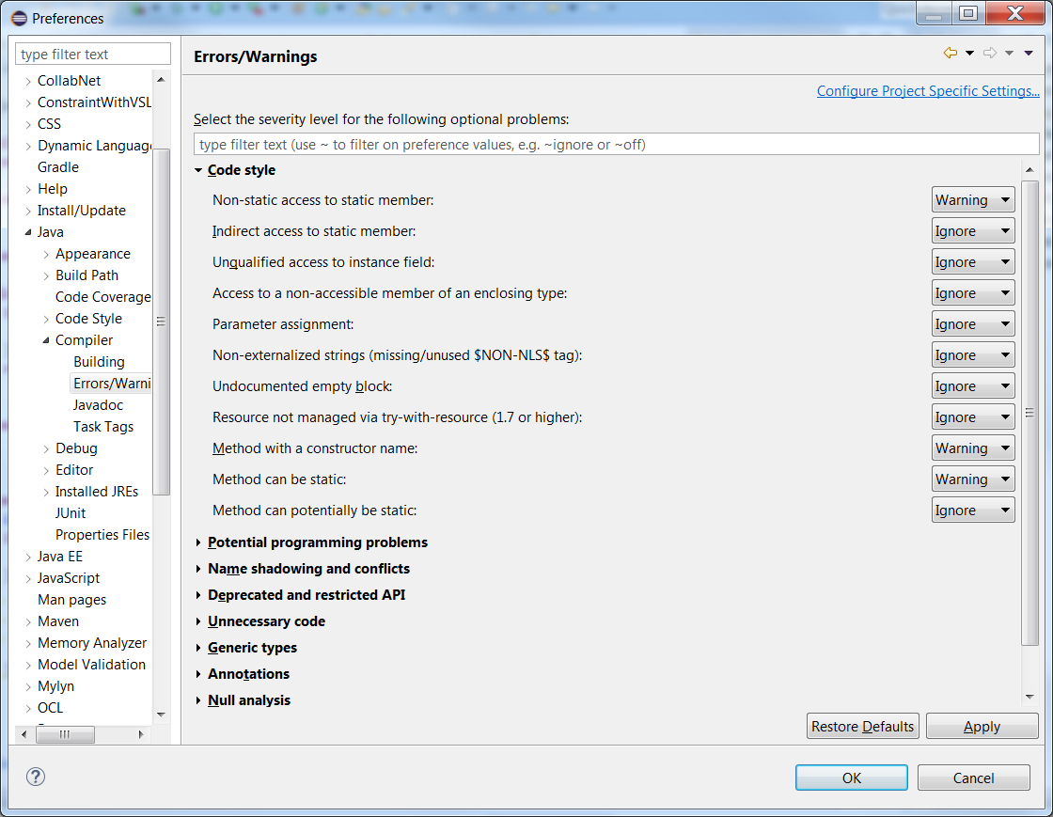

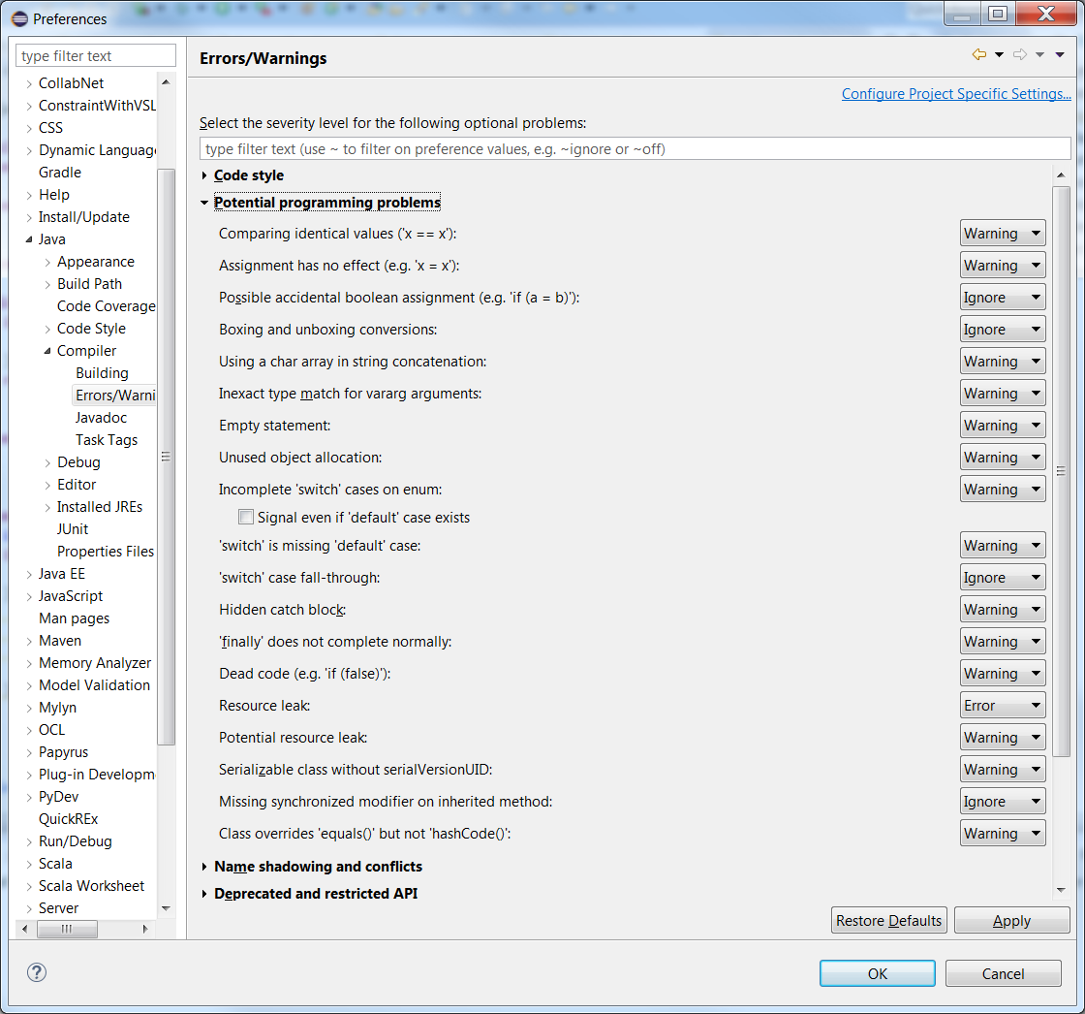

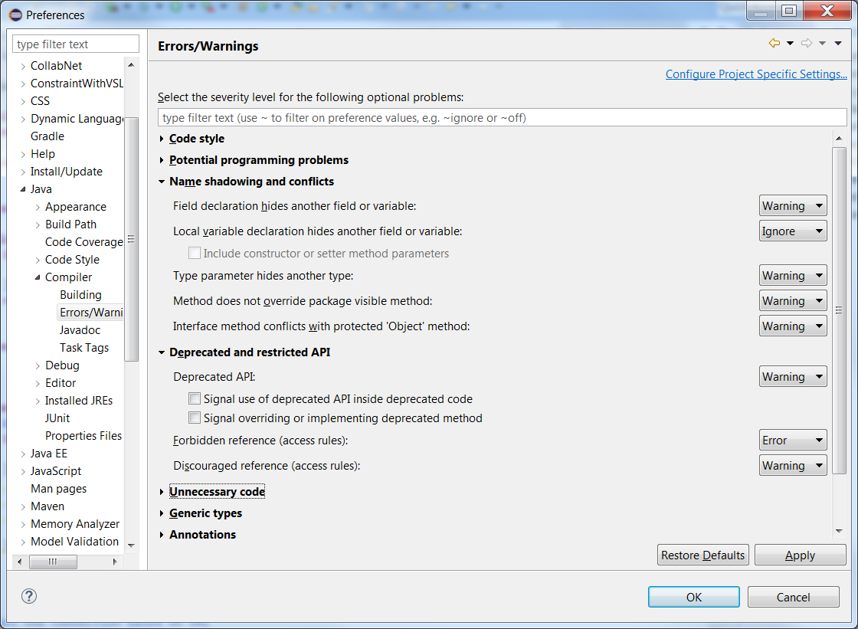

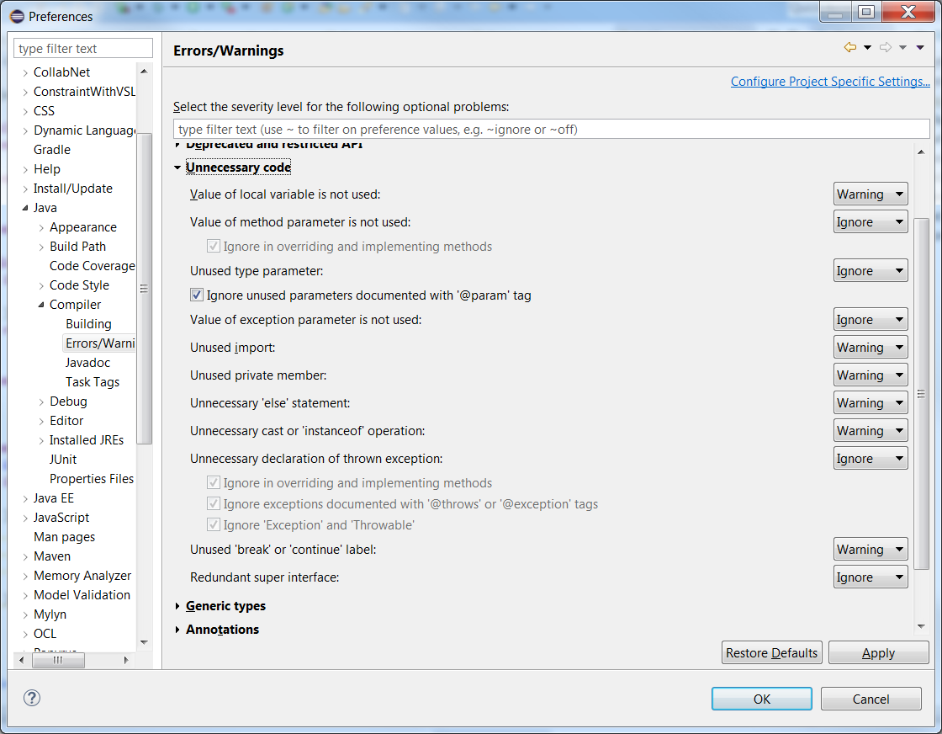

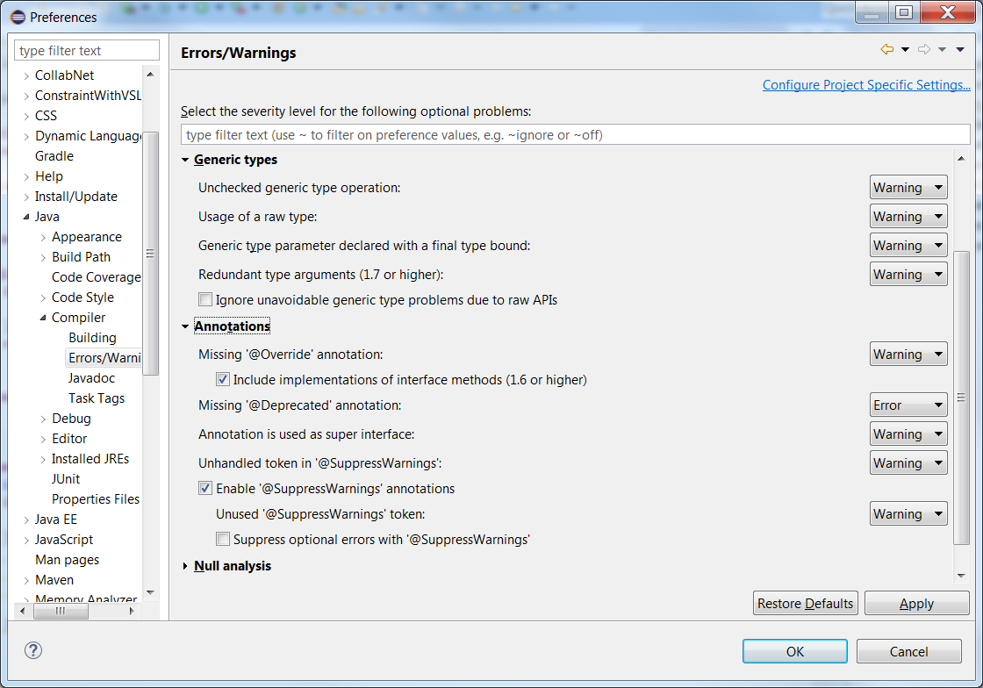

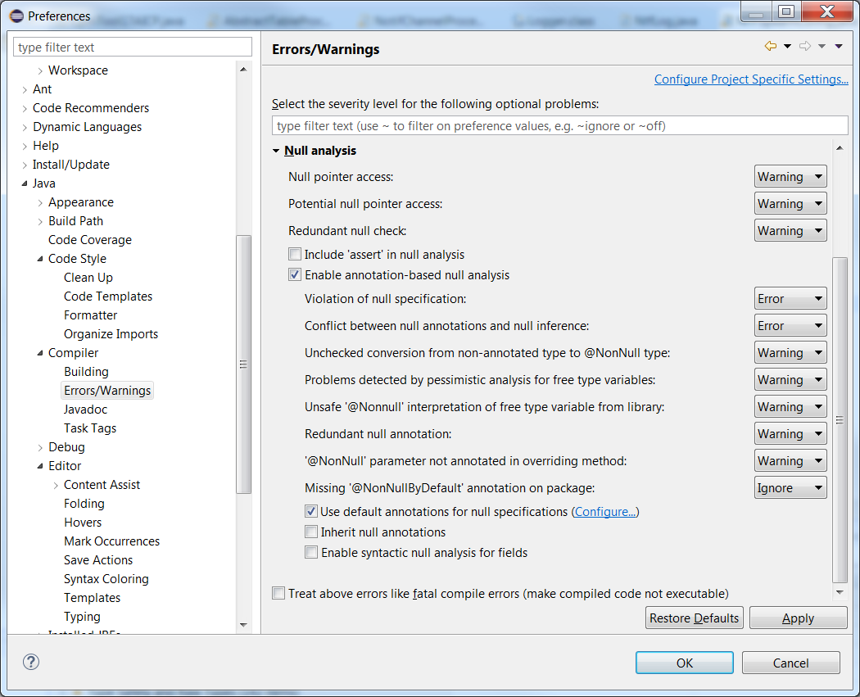

## Java – Compiler – Javadoc

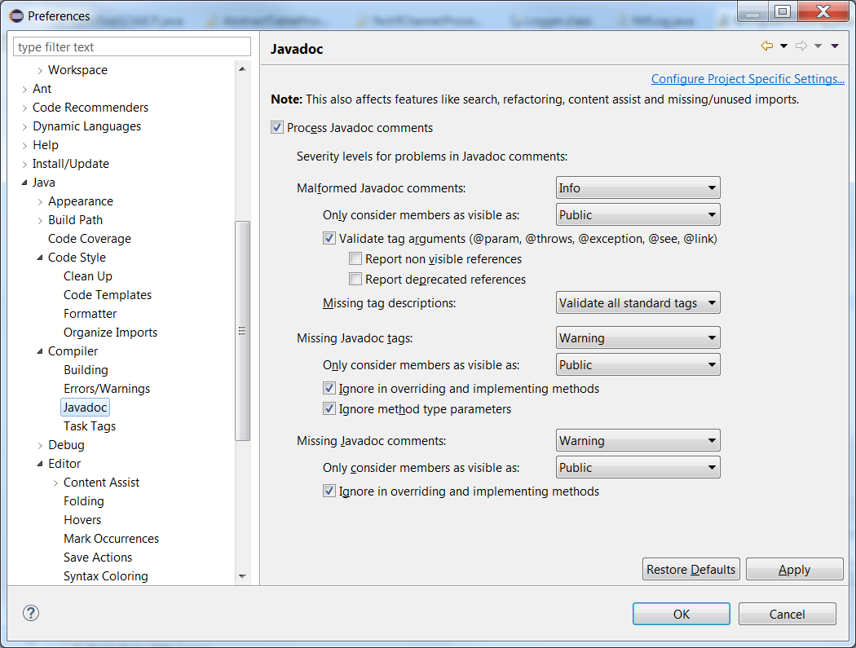

## Maven – Errors/Warnings

